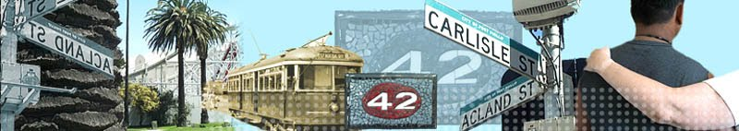
2015
Gayle Wood
The First Step Program
3rd July 2015
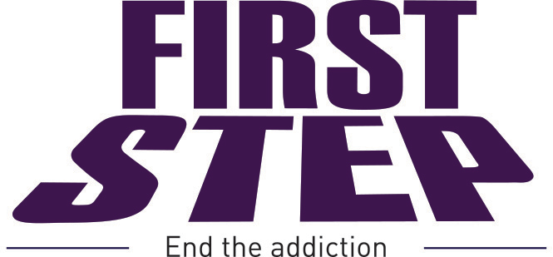
First Step Program Information Handbook
Table of Contents
3 | Welcome to the First Step Program
4 | Our vision and mission statement
6 | Who we are and what we do
8 | A pioneer in drug and alcohol treatment in the heart of St Kilda
9 | A unique wrap around service
9 | Addiction medicine
10 | Practice staff
11 | Practice hours
12 | Management of your personal health
13 | The First Step Legal Service
14 | The Second Step Employment Program
15 | Donations
16 | Sponsors



Welcome to the First Step Program

It is with pleasure that I introduce you to the First Step Program.
The core focus of the First Step Program is to provide specialist drug, alcohol and mental health services. We provide high quality health care to people who are suffering from addiction in Victoria. We rely on the efforts of staff across a wide range of roles to enable, support and delivery of this care.
As you will see from the handbook, the First Step Program is quite diverse in the range of services that it provides. We are situated in the inner city of St Kilda and provide a service to a range of socially, culturally and linguistically diverse in population.
Operationally, we are a relatively small organisation who provides a varied range of services to around 1500 clients in any one year. It is through the expertise and commitment of staff that we continue to both deliver and develop the program to meet the needs of the community who are suffering from mental health or addiction issues.
The First Step Program’s vision, mission and values outline how we aim to address these challenges and how we wish to be as an organisation.
We encourage our staff to improve services through a range of initiatives including education sessions, regular staff meetings and sub-committee meetings.
As you read through the information contained in this handbook I strongly encourage you to make contact with the First Step Program and make a time to visit and speak with the many experienced and knowledgeable staff and draw on their expertise to provide you with information pertaining to the First Step Program.
I also urge you to make the most of opportunities that will enable you to contribute to the First Step Program and commitment to facilitate better health outcomes for our clients who are suffering from addiction and mental health issues.
I thank you in anticipation of your support,
Bryan Ambrosius
Chief Executive Officer
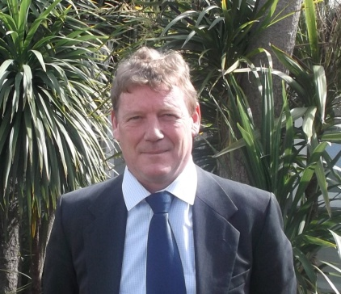

Our vision and mission statement

Vision
Our vision is a community free from addiction and substance abuse related issues and the problems it creates in people’s lives.

Mission
The First Step Program will provide safe and effective pathways to recovery for all people with addiction and substance abuse related issues, to assist them to positively engage with the community.

To enact this mission we are committed to:
Affordability and Accessibility
We aim to provide affordable, accessible and non-judgemental services to all who seek assistance.
Medical Programs
We provide an environment in which staff members work with people to determine which of our range of medical treatment programs are appropriate for them. These programs include treatment for addiction, mental health problems and Hep C.
Psycho–Social Programs
We provide compassionate advice, referral, support and counselling.
Legal Program
We provide access to a free legal service for those engaging in our treatment programs who face criminal proceedings in the Victorian Legal System.
Vocational Support
We provide pre-vocational training and counselling programs and opportunities for employment with participating businesses.
Research and Innovation
We pioneer innovative treatments and seek to influence public drug policy.

Values
Every aspect of the operation of The First Step Program aims to maximise the well-being of all people seeking its help.

Accessibility
The First Step Program believes in the rights of all people, regardless of their financial status or other factors, to receive assistance in overcoming obstacles in their lives. We believe in the right of all individuals to flourish, and our aim is to assist people to maximise their long term happiness.

Compassion
The First Step Program maintains a compassionate approach to its relationships with all people. All visitors to the practice are treated as individuals deserving of assistance in whichever way we are able to offer it.

Respect
The First Step Program always operate in a manner that shows respect to clients, their families, staff and volunteers in the belief that such an environment enables the best outcomes for all these groups.

Innovation
By recognising the changing nature of drug use and maintaining a flexible approach to all aspects of the treatment of drug dependence, the practice takes full advantage of new developments in the field, and periodically reviews its existing treatment methods. The practice also encourages external policy makers to remain open-minded about new treatment methods and advocates for the acceptance of proven progressive interventions.

Excellence
The First Step Program continually aims for excellence in caring for the physical and mental health of clients, their families, staff and volunteers.

Passion and Appreciation
The First Step Program exists due to the passion of its staff, volunteers and founders. The program strives to maintain an environment that fosters this passion, and publicly and frequently expresses its gratitude to all its team members.
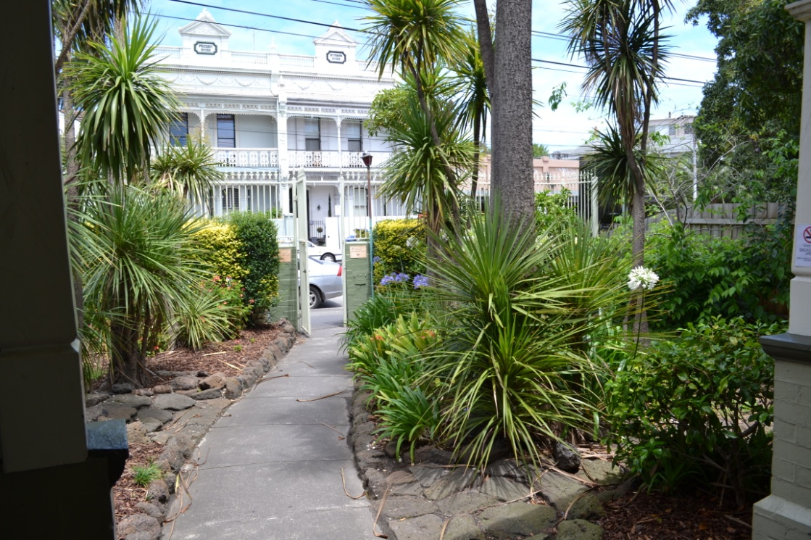

Who are we are and what we do
The First Step Program was founded in July 2000 due to the energies and enthusiasm of two men: Peter White and Dr Simon Rose. Dr Rose, in part due to his work as a physician with women in the sex industry, became acutely aware of the damage that heroin was doing to the lives of many people.
Peter White had found it necessary to take his own daughter to Perth to undergo Dr George O'Neil's Rapid Induction Program a type of rapid detox using naltrexone for heroin dependence. Peter White, a businessman, purchased and renovated the current property at 42 Carlisle St, St Kilda, with the goal of making available medical services similar to those provided by Dr George O'Neil in Perth.
In the thirteen years since the First Step Program opened, we have developed a reputation for being a compassionate, respectful medical and psycho-social program that cares for people with a dependence on drugs or alcohol.
The First Step Program prides itself on achieving a balance between conventional treatment methods, such as replacement pharmacotherapy programs (eg. methadone, buprenorphine) or psychological counselling and more innovative treatments such as naltrexone. Each individual's safety and health are the absolute priority of all staff at the First Step Program and extensive counselling is available to patients undergoing any form of treatment.
The First Step Program provides a comprehensive range of medical programs and psycho-social programs (such as counselling and employment assistance). The field of addiction medicine is a complicated one with much disagreement among professionals about which treatments are the most effective. However, everyone agrees on one thing:
Drug or alcohol addiction is a chronic, relapsing illness, and a comprehensive approach that considers many aspects of a person’s life is the surest path to rehabilitation.

There is another maxim by which the First Step Program operates:

Determining the best intervention or combination of interventions is as important as the quality of those interventions.
It is important that clients and family members come to the First Step Program with an open mind. Someone may think that they definitely want to go on the methadone program for example. However, it takes multiple, thorough consultations for our addiction medicine specialists, working with their patients, to determine the safest and most effective path in each case.
The First Step Program focuses on getting clients well

In a typical day at the First Step Program
- We provide a comprehensive service to clients in need who are suffering from addiction or mental health issues
- Treat approximately 60 clients per day
- See clients who have been referred through other services including clients who have been discharged from hospital
- Liaises with other services regarding the care of our clients
- Provide a range of services to the clients who attend the First Step Program
- Provide comfort, support and a range of administrative tasks to the clients who access the program
- Refer clients who require care outside of what the First Step Program can provide in a timely and professional manner
- Support the clients and families of people suffering from addiction with compassion and care at all times

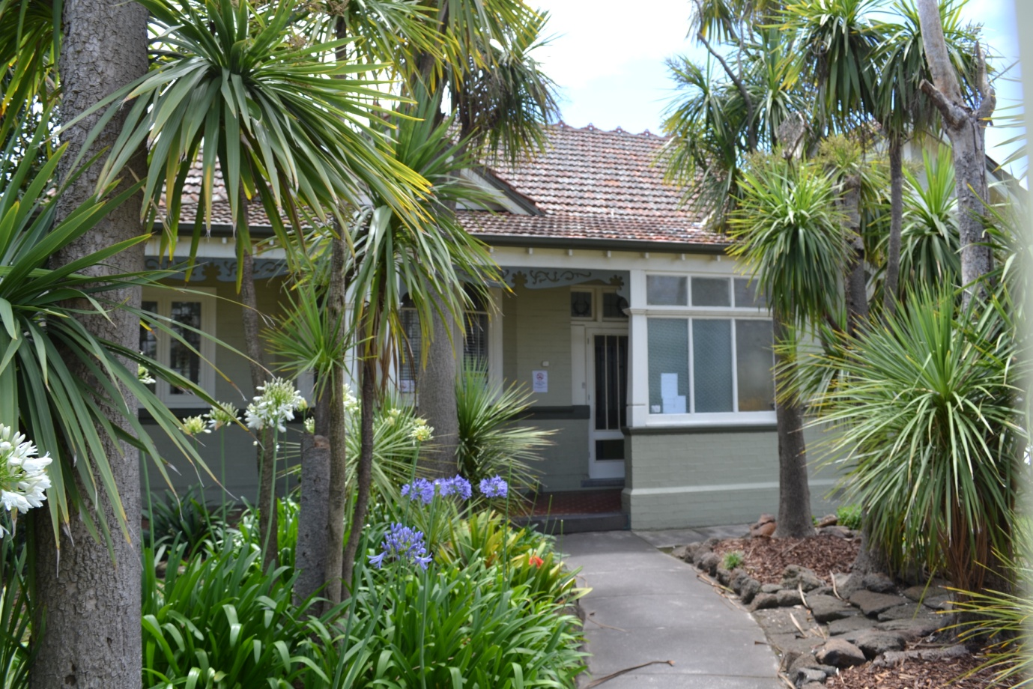

A pioneer in drug and alcohol treatment in the heart of St Kilda
The problem
The effects of alcohol and drug dependence on hundreds of thousands of Australians is devastating, and the effects on their families and communities can seem insurmountable.
Most services available to people with a drug or alcohol dependence have a relatively narrow focus, be that medical, psycho-social, legal, vocational et at. Clients are left bouncing from one service to another without a cohesive vision and pathway to full health and reintegration into the community.
Some brief facts and stats
The social cost of illicit drug use in Australia was estimated at $8.2 billion in 2004–05, including costs associated with crime, lost productivity and healthcare. Illicit drug use accounted for 2.0% of Australia’s total burden of disease in 2003. Much of this was caused by hepatitis C, which can be contracted by risky injecting practices. Around 8% of people in Australia aged 16–85 years have had a drug use disorder (including harmful use/abuse and/or dependence) in their lifetime. (Australian Institute of Health and Welfare 2010)
The solution
The First Step Program is a multidimensional ‘one-stop-shop’ model. It is a program whereby a person suffering from addiction, substance abuse and mental health issues can receive treatment to understand and assist with their complexity of need. The services work in a Recovery Orientated Framework in line with departmental health guidelines. The First Step Program is capable of tackling the multiplicity of barriers usually experienced by a person struggling with these issues; it offers the possibility of finding a pathway from incapacity and unemployment to health and employment. The First Step program is predominately funded by Medicare. Patients of the First Step Program can access General Practitioners, Psychologists, Psychiatrists, Social Workers, Mental Health Nurses, Addiction Medicine Specialists and Hepatitis C Consultants through Mental Health Treatment Plans, keeping the costs to clients to a minimum.
How is it different?
In addition to the multidimensional treatment model, the First Step Program offers two additional services that, in combination, distinguish the Program from other drug and alcohol treatment clinics and increase the likelihood of long-term rehabilitation in relation to addiction and substance abuse issues. The Program is both innovative and unique through the incorporation of the First Step Legal Service and the Toll Second Step Program (supported employment).


A unique wrap around service
As a not for profit organisation the First Step Program aims to provide the best possible service to all people regardless of their financial status or other factors, to receive assistance in overcoming obstacles in their lives. We believe in the right of all individuals to flourish, and our aim is to assist people to maximise their long-term happiness.
The First Step Program does not receive any government grants and we rely heavily on the financial support that is received through Toll Holdings, philanthropic organisations and donations sourced through grants and tenders.
The clients who access the First Step Program are sometimes socially and economically disadvantaged and it requires the innovative and strategic planning of a strong board and staff to maintain the high standard that is provided at the First Step Program. Addiction crosses many lives and we aim at the First Step Program to keep our costs to a minimum so as to provide the best possible service to all clients who wish to access treatment.
The First Step Program has a proud history of providing specialised care to people with a dependence on drugs or alcohol. It has always been a priority of the First Step Program to provide an atmosphere of genuine compassion, an environment where people are comfortable and feel understood.
The First Step Program is increasingly focused on a team approach to whole-patient care, which often includes ongoing support for family members and carers. At the First Step Program clients have access to doctors, nurses, psychologists, mental health care nurses, counselors and hepatitis C clinicians. There are many stages to overcoming dependence, and the First Step Program can help clients through every one of them.
Affordability and accessibility are central to the First Step Program’s mission. Treatment costs can be a key disincentive to people seeking help for drug and alcohol dependence which is why all the First Step Program consultations are bulk-billed. Making people well is our mission and barriers to treatment such as fees for services can be minimised or, in most cases, avoided entirely.

For the first time I felt that I was being asked the right questions and all the little things that no one listened too where finally heard
Matt – Patient First Step

Practice staff
Bryan Ambrosius Chief Executive Officer
Gayle Wood Operations Manager
Roslyn Osborne Practice Manager
Patrick Lawrence Manager Special Projects
Dom Behan Client Services Co-ordinator

Practice medical staff
Dr John Gunzburg Addiction Medicine
Dr Robyne Klein Addiction Medicine
Dr Naren Morris General Medicine
Dr Peter White General Medicine

Mental health nurses
Chris Schaffer Manager Nursing Services
Clara Summers Mental Health Care Nurse
Joe Fishburn Mental Health Care Nurse
Jane DeVilliers Mental Health Care Nurse
Practice nurse
Haydn Salomons Practice Nurse

Psychologists
Dr Michael Faulkner Dr Jan Borrell Sally Connell

Infectious diseases specialist
Dr Suman Majumdar

Hep C clinical nurse consultant
Sally Watkinson

First Step legal service
Tania Wolff Principal Lawyer
Janine Perlman Lawyer
Bess Smallwood Legal Case Manager

Practice Hours (by appointment only)
Monday, Wednesday, Friday: 9am – 5pm Tuesday, Thursday 9am-7pm

Drug and alcohol services
Maintenance treatment (methadone, buprenorphine, suboxone)
Buprenorphine to naltrexone transfer
Naltrexone tablets
Home detox support
Psychiatry
Hep C advice/treatment.
Mental Health Nursing
Psychological counseling

Psycho-social services
Second Step Employment Service
First Step Legal Service

Appointments
Please phone 9537 3177 every effort will be made to accommodate a preferred time and clinician. Emergencies will always be given priority and reception staff will attempt to contact a client if there is any unforeseen delay or a clinician has been called away. Longer consultation times are available, so please ask reception if a longer time is required.
If a client or a family member requires an interpreter service please speak with a member of the administration team.

Telephone access
Clinicians at the First Step Program may be contacted during normal hours. If a clinician is unavailable then a message can be left with reception staff. Calls will always be put through to a clinician in an emergency.

Email
General enquiries can be made via info@firststep.org.au

Fees and billing arrangements
All regular appointments with the doctors, mental health nurses and psychologists are bulk billed.

Management of your personal health Information
All medical records are confidential. It is the policy of the First Step Program to maintain the security of personal health information at all times and to ensure that this information is only available to authorised members of staff.
We abide by the ten National Privacy Principles available at: www.privacy.gov.au

The First Step Program has a no smoking policy
Smoking can only be undertaken in the driveway

Client rights
If a client has a problem we encourage them to contact us. This can be done either in person or in writing. We take client concerns, suggestions and complaints seriously. Complaint forms can be obtained from the Operations Manager. If clients feel that they would like to report any aspect of the clinic to a higher authority, they are encouraged to contact the Victorian Health Services Commissioner on 1800 136 066.

Care outside normal opening hours
The First Step Program works in partnership with the Melbourne Medical Locum Service to provide its clients with 24-hour medical care. Please contact after hours on 9429 5677.
If your situation is critical or life-threatening call 000 immediately.



The First Step Legal Service
The First Step Legal Service (FSLS) provides well-resourced, fully integrated pro bono legal representation to approved clients. Many of the clients of the First Step Program face criminal proceedings in the various courts throughout Victoria. The stress of legal proceedings can often result in periods of relapse and reoffending. Therefore the aim of the First Step Legal Service is to support the clients throughout this stressful period and to provide the Court with a comprehensive analysis of all matters in mitigation, including the extensive rehabilitation undertaken by the client. This ensures that any sentence imposed furthers the process of rehabilitation and increases the prospect of the client reengaging in society as a functional member. In turn, this ultimately benefits society.
The First Step Legal Service recently produced a study analysing the low rates of recidivism of FSLS clients. This may be attributed to the following:
1. The full resources of First Step Program’s clinical team are made available to the First Step Legal Service (subject to relevant authorities), enabling the legal team to present an insightful, comprehensive and current portrayal of our clients’ prospects of rehabilitation. This usually includes reports and/or evidence from the clinicians at the First Step Program, along with supporting material from other services, character referees and Second Step Program progress reports.
2. The accessibility and proximity of the multidimensional services of the First Step Program (under the one roof) often promotes a transfer of trust of the clients from the clinical staff to the legal staff, thereby facilitating effective communication.
3. Clients receive a high level of support before, during and after their involvement with the Courts. This is achieved through the open communication channels between the clinical staff and the legal team. However, with further funding enabling more extensive follow up, this process could become significantly enhanced.

4. There is the further benefit, that the pending legal proceedings offer an added incentive to the client to increase the momentum of treatment and accelerate the process of rehabilitation.
Any current First Step Program clients can request access to the First Step Legal Service; however, due to limited funding, the demand for the Service far exceeds those who are accepted.



The Second Step Employment Program
The Second Step Employment Program is a specialist employment service designed to provide employment opportunities to people who experience barriers to employment. This may include prior criminal offending, long-term unemployment, history of addiction and substance abuse.

The Second Step Program aims to assists the transition back into employment by providing:

- real jobs,
- access to support services to further rehabilitation,
- mentoring,
- flexibility to enable the time to re-engage with the ‘normal’ working world,
- development or re-establishment of routines, habits and relationships to enable the individual to function and flourish in this environment,
- acknowledgement and accommodation of past undesirable history, focusing on the participants potential rather than their past,
- establishment of partnerships with rehabilitation programs who have the expertise and experience to provide specific care and support required beyond the work place.
In its most effective form, the Second Step Program draws on the expertise of the various partner programs and community agencies to ensure that the participant has access to all necessary supports. Thus, the employer is in a position to concentrate on work related issues with the knowledge that the other components are being effectively managed. The interaction between employer and the partner program significantly reduces the risk of ‘surprise issues’ (such as relapse) and ensures effective case management, which, in turn, maximizes the potential for successful outcomes.



Donations
You can help the First Step Program by sending or encouraging others to donate to the First Step Program

Donations to the First Step Program are fully tax deductible as we are a registered not for profit organization.
Your donations can be sent in the following ways

By cheque or money order to The First Step Program
42 Carlisle Street
St Kilda 3182

By direct bank deposit The First Step Program
BSB #633-000
Account #129250031

By Monthly Donation If you can you can donate a certain amount of money each month, our monthly donation system is fully automated and secure. Donations are processed on the 15th of each month and an annual receipt will be issued to you in July of each year.

By Our Community Log onto the website http://www.givenow.com.au/ and follow the links to the First Step Program donation page.
Via the Website Log onto the website www.firststep.org.au and follow the prompts to the donations page
We thank you in anticipation of your support, the First Step Program relies heavily on the generous donations of corporate organizations, philanthropy and general donations through word of mouth of the excellent work that is being achieved for our clients. The First Step Program does not receive any government funding.

Sponsors

The First Step Program would like to thank the following business for their support



Community Second Step Program

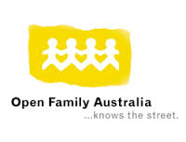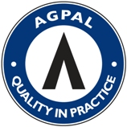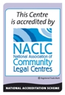

The First Step Program
42 Carlisle Street
St Kilda 3182
Phone : 9537 3177 Fax: 9537 0133
Email: info@firststep.org.au
Website: www.firststep.org.au

